**РАБОТА С БАЗОЙ ДАННЫХ**

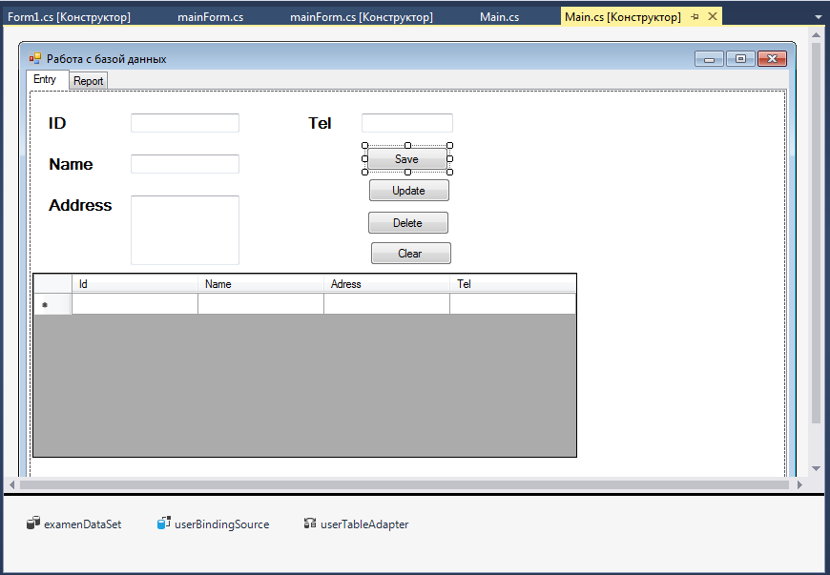

using System;

using System.Collections.Generic;

using System.ComponentModel;

using System.Data;

using System.Drawing;

using System.Linq;

using System.Text;

using System.Threading.Tasks;

using System.Windows.Forms;

using System.Data.SqlClient;

namespace Exam

{

public partial class Main : Form

{

SqlConnection connection = new SqlConnection(@"Data Source=1-PC\SQLEXPRESS;Initial Catalog=Examen;Integrated Security=True");

public Main()

{

InitializeComponent();

}

private void Main_Load(object sender, EventArgs e)

{

// TODO: данная строка кода позволяет загрузить данные в таблицу "examenDataSet.User". При необходимости она может быть перемещена или удалена.

connection.Open();

this.userTableAdapter.Fill(this.examenDataSet.User);

load_data();

}

void load_data()

{

SqlDataAdapter sqlData = new SqlDataAdapter("SELECT*FROM [User]", connection);

DataTable data = new DataTable();

sqlData.Fill(data);

dataGridView1.DataSource = data;

}

void clear_fun()

{

id_txt.Text = "";

name_txt.Text = "";

ad_txt.Text = "";

tel_txt.Text = "";

}

private void save_btn_Click(object sender, EventArgs e)

{

SqlCommand command = new SqlCommand("INSERT INTO [User](Id, Name, Adress, Tel) VALUES ('" + id_txt.Text + " ',' " + name_txt.Text + "' , '" + ad_txt.Text + "' , '" + tel_txt.Text + " ')", connection);

command.ExecuteNonQuery();

load_data();

clear_fun();

MessageBox.Show("saved");

}

private void clear_btn_Click(object sender, EventArgs e)

{

clear_fun();

}

private void update_btn_Click(object sender, EventArgs e)

{

SqlCommand command = new SqlCommand("UPDATE [User] SET Name='" + name_txt.Text + "', Adress='" + ad_txt.Text + "', Tel='" + tel_txt.Text + "' where id='" + id_txt.Text + "'", connection);

command.ExecuteNonQuery();

load_data();

clear_fun();

MessageBox.Show("Updated");

}

private void delete_btn_Click(object sender, EventArgs e)

{

SqlCommand command = new SqlCommand("DELETE FROM [User] WHERE Id='" + id_txt.Text + "'", connection);

command.ExecuteNonQuery();

load_data();

clear_fun();

MessageBox.Show("Deleted");

}

private void dataGridView1_CellClick(object sender, DataGridViewCellEventArgs e)

{

int Num = dataGridView1.CurrentCell.RowIndex;

id_txt.Text = dataGridView1.Rows[Num].Cells[0].Value.ToString();

name_txt.Text = dataGridView1.Rows[Num].Cells[1].Value.ToString();

ad_txt.Text = dataGridView1.Rows[Num].Cells[2].Value.ToString();

tel_txt.Text = dataGridView1.Rows[Num].Cells[3].Value.ToString();

}

}

}